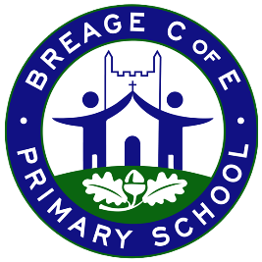

Maple Class Autumn 1 2025
Key Questions - Who am I and where do I come from?
Have toys changed since our grandparents were young and how do we know?

Book Spine
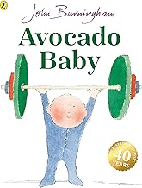  Nursery Rhymes  1,2,3,4,5 Once I caught a fish alive  A sailor went to sea  Pat-a-cake | EYFS  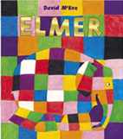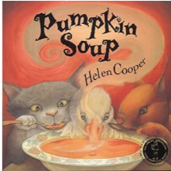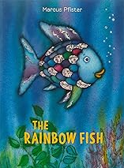 | KS1  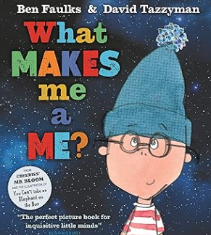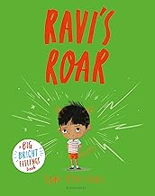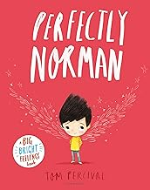

 |  | 5th Sept  (2 days) | 8th Sept | 15th Sept |  |  | 22nd Sept | 29th Sept |  | 6th Oct |  |  | 13th Oct |  | 20th Oct
English | Key dates | 3rd– INSET Price training  4th – Tier 2 safeguarding training |  | 15th: Cognition and learning in to observe EW and staff meeting @ 3:15-4:15 on precision teaching (all staff)  16th: Meet the teacher meeting KS1 and 2.  17th MB DSL training (Lauren to cover AM) |  |  | 22^{n: Iona in}  25th – HoS meeting | 29th – West Hub council meeting  1st – Disadvantaged network meeting  2nd: MB @ Reception and SENCo network meeting 9:00-3:00 |  | 10th – Harvest Festival  EYFS Wordless books to be given out this week |  |  |  |  | 20th (monday) MB Boxall training – all day  24th -Aspire INSET day (Support staff to attend)
English | C & L  (EYFS) | Nursery - Starting to use talk with familiar adults and peers creating sentences in their play  Following instructions  Answering questions (what, who, where, when)  YR - Following instructions  Turn Taking  Share ideas and thoughts with adults and peers- using talk
English | Literacy  (EYFS) | Nursery - Phase 1 Phonics  Developing mark making skills through gross motor movements  Join in with stories, rhymes and songs  YR - Revisit phase 1 skills  Listening  Discrimination of sounds  Initial sounds  Mark Making  Name writing  Fine motor- pencil control  Listen to stories and retell
English | Key Texts | Rainbow Fish – Marcus Pfister | ‘What makes me me’– Ben Faulks |  | Perfectly Norman – Tom Percival | Ravi’s Roar – Tom Percival |  |  | ‘Elmer’– David McKee |  | ‘Avocado Baby’ John Burningham | ‘Pumpkin Soup’– Helen Cooper
English | Phonics  Reception  Year 1  Year 2 |  | S, a, t, p, |  | i, n, m, d | G, o, c, k  is |  |  | Ck, e, u, r,  I |  | H, b. f. l  the | Assess and review
English | Phonics  Reception  Year 1  Year 2 |  | ai ee igh oa |  | oo oo ar or  was you they | ur ow oi ear  my by all |  |  | air er words with double letters: dd mm tt bb rr gg pp ff  are sure pure |  | longer words | Assess and review

Writing
SPAG

 | Writing  SPAG | *Focus on transcription |  |  |  |  | The Place Value of Punctuation and Grammar
Maths | Maths  (EYFS) | Nursery - Subitise up to 2  Recite numbers past 5  Make comparisons between objects- size, length, weight and capacity  Use shapes for building thinking about their properties e.g. flat sides for stacking  Spot patterns and talk about them e.g. stripes on a scarf  YR - Matching and comparing amounts  Representing, comparing and composition of numbers to 3 including subitising  Circles and triangles  Compare mass, length and capacity  Exploring pattern
Maths | N |  |  | Nursery | Block 1 | Comparison 1 – More than, fewer than, same |  |  | Nursery | Block 2 | Shape, space and measure 1 – Explore and build with shapes and objects |  |  |  |  | Nursery | Block 3 | Pattern 1 – Explore repeats
Maths | YR |  |  | Match, sort  and compare  Step 1 Match objects  Step 2 Match pictures and objects  Step 3 Identify a set  Step 4 Sort objects to a type  Step 5 Explore sorting techniques | Match, sort  and compare  Step 6 Create sorting rules  Step 7 Compare amounts |  | Talk about measure  and patterns  Step 1 Compare size  Step 2 Compare mass  Step 3 Compare capacity |  |  | Talk about measure  and patterns  Step 4 Explore simple patterns  Step 5 Copy and continue simple patterns  Step 6 Create simple patterns |  | It's me  1, 2, 3  Step 1 Find 1, 2 and 3  Step 2 Subitise 1, 2 and 3  Step 3 Represent 1, 2 and 3 |  | It's me  1, 2, 3  Step 4 1 more  Step 5 1 less  Step 6 Composition of 1, 2 and 3 | Assess and Review
Maths | Y1 / Y2 |  |  | Place Value (within 20)  Pre-block assessment  Step 1 Count objects within 10  Step 2 Represent numbers to 10  Step 3 Count on and back within 20  Step 4 Understand 10 | Place Value (within 20)  Step 5 Understand 11 – 15  Step 6 Understand 16 – 20  Step 7 1 more  Step 8 1 less  Step 9 Number lines |  | Place Value (within 20)  Step 10 Estimate on number lines  Step 11 Less than, greater than, equal to  Step 12 Compare numbers  Step 13 Order numbers  End of block assessment |  |  | Addition & Subtraction (within 20)  Pre-block assessment  Step 1 Parts and wholes  Step 2 Systematic number bonds within 10  Step 3 Number bonds to 10  Step 4 Number bonds to 20 |  | Addition & Subtraction (within 20)  Step 5 Addition – add together  Step 6 Addition – add more  Step 7 Doubles  Step 8 Near doubles  Step 9 Add three 1-digit numbers |  | Addition & Subtraction (within 20)  Step 10 Find a part  Step 11 Fact families – the eight facts  Step 12 Take away (how many left?) | Addition & Subtraction (within 20)  Step 13 Find the difference  Step 14 Missing number problems  End of block assessment
RE | F1 GOD/  CREATION: Why is the word ‘God’ so important to Christians? |  |  | WALT: I can know why God is important to Christians (linked to the creation story) | WALT: I know why Christians celebrate harvest |  | WALT: I can say how Chritians take care of the world |  |  | Preparations for harvest festical |  | Harvest festival church service |  | WALT:I I understand why Chritians refer to God as ‘hallowed’ in the lords prayer. | WALT:I can reflect what I want to keep safe in my life and say why
Theme | UtW  (EYFS) | Nursery - Begin to make sense of their own life story  Show interest in different occupations  Talk about what they see using a wide vocabulary  YR - Discussion about families and their similarities and differences- link to books about families from the past e.g. Peepo, etc.  Materials and their properties  Describe and explore local environment - link to maps of the local area
Theme | History / Geog: | How do we know that toys changed since our grandparents were young?
Theme | History / Geog: |  |  |  |  | Step 1: How can we find out about the past? |  | Step 2: What are our toys like now? | Step 3: What was my favourite toy when I was a baby? |  | Step 4: What were our parents’ toys like? How do we know? |  | Step 5: What were our older relative’s toys like? How do we know? |  |  | Step 6: How have toys changed since our older relatives?
Theme | Science | EYFS - Animals  Name different animals.  Know where different animals live.  Know what animals need to survive.  Compare animals.
Theme | Science | Why do seasons change (Autumn / Winter)?  Note, seasonal changes discussed throughout the year and through CP
Theme | Science |  | 1. What are signs of Autumn? |  |  | 2. What is the weather like in Autumn? |  | 3. What are signs of Winter? | 4. What is the weather like in winter? |  | 5. What happens to the day length in winter?
Theme | EAD  (EYFS) | Explore the use of colour and design  Explore tools and their uses  Colour identification  Colour mixing
Theme | Art / DT | Portrait inspired by Andy Warhol using natural and found objects- links to knowing the primary and secondary colours.  What makes a portrait effective or appealing?
Theme | Art / DT |  |  |  |  | Step 1: Who is Andy Warhol and what is distinctive about his art? |  | Step 2: What materials can be used in creating art? | Step 3: How do different materials affect the texture of art? |  | Step 4: What can we learn from sketching and planning a portrait? |  | Step 5: How does repetition change the impact of an image? |  |  | Step 6: What makes a portrait effective or appealing?
PSHE | SCARF  Me and my relationships |  |  | My Feelings (R) | My Feelings (2) (R) |  | Good friends (Y1) |  |  | How are you listening? (Y1 |  | Types of bullying (Y2) |  | Being a good friend (Y2) | Let’s all be happy (Y2)
PSHE | PSED  (EYFS) | Nursery - Rules and responsibilities linked to feelings  Healthy lifestyles (inc teeth, food, exercise)  YR - Class Rules and responsibilities linked to feelings  Building independence  Healthy lifestyles
PE | PE | DT Coaching
PE | Physical Development  (EYFS) | Nursery - Revise and use fundamental movement skills e.g. run, jump hop  Use core muscle strength to achieve good posture (start to develop handwriting posture)  YR - Develop the skills needed to get through the school day e.g. lining up  Revise and use fundamental movement skills

Prime Areas
Personal, Social & Emotional Development
Meeting new friends, learning new names, settling into new rules and routines. Sharing resources and taking turns. Finding resources for myself and tidying up. Asking for help and trying new things. Following simple instructions and watching my teacher. Our Jigsaw theme is called ‘Being Me in My World’.
Communication and Language
Talking about myself and listening to others to talk. Listening to new and familiar stories with my class. Learning new words and using them in my play.
Physical Development
Being able to move, stop and be still. Following instructions to keep safe. Practising spatial awareness and movement games. Using simple tools to make marks and begin to use scissors to snip. Practising simple self-help skills, e.g. putting on coats and wellies and washing hands.

Understanding the World –
Talking about myself and my family and the things that we like to do. Listening to others and understanding that families are all different. Talking about and recognising differences in how we celebrate in our families and compare changes over time. Identifying things our local environment.
Expressive Arts and Design – Learning to sing some new Autumn songs and explore new vocabulary. Using simple percussion to tap rhythms. Drawing myself and using simple collage materials with support. Exploring pattern

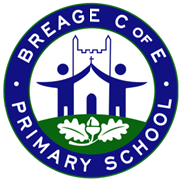
Autumn Term 1
Maple Class EYFS
Specific Areas
Literacy –
Listening to key texts related to the topic.
Learning to read simple sounds (phonemes) and to write them (graphemes).
Practising segmenting and blending sounds together to read and write simple cvc words.

Maths –
Matching and sorting by colour, shape and size. Class routines and where do things belong. Key positional language. Mathematical texts. Exploring new mathematical resources and language. Subitising.

