
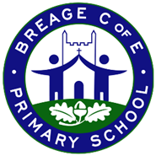
Class KS1 Curriculum - Autumn 1

Geography | Science | Art | PE | Computing
My Community  What is the geography of where I live? | Why and how do seasons change? | Self- Portraits  What makes a portrait effective or appealing? | Introduction to PE: Unit 1  Fundamentals | Digital Literacy: Internet Safety  Awesome Autumn /  Robots
Walk of the Local Area  Sequence of lessons:  1 - What is the name of the town / village I live in?  2 - Where is my home area on a map of the United Kingdom?  3 - What are the key physical and human features of my locality?  4 - How do I make a map or plan?  5 - How does my local area compare with somewhere else in the country (London)?  6 - How can I use aerial photographs and plan perspectives to recognise features? | Sequence of lessons:  1. What are signs of Autumn?  2. What is the weather like in Autumn?  3. What are signs of Winter?  4. What is the weather like in winter?  5. What happens to the day length in winter? | Sequence of lessons:  Step 1: Who is Andy Warhol and what is distinctive about his art?  Step 2: What materials can be used in creating art?  Step 3: How do different materials affect the texture of art?  Step 4: What can we learn from sketching and planning a portrait?  Step 5: How does repetition change the impact of an image?  Step 6: What makes a portrait effective or appealing? | Sequence of lessons:  1. To explore balance, stability and landing safely.  2. To explore how the body moves differently when running at different speeds.  3. To explore changing direction and dodging.  4. To explore jumping, hopping and skipping actions.  5. To explore co-ordination and combination jumps.  6. To explore combination jumping and skipping in an individual rope. | Internet Safety: Children explore internet safety concepts at an appropriate level through retelling of stories and discussion. Children explore safe use of technology along with other physical items within their settings.  Moving a robot  - Buttons  - Directions  - Forwards and backwards  - Four directions  - Getting there  - Routes
Outcome:  Make a large scale map / model of Breage Village | Outcome:  Seasons showcase – Children present their learning to parents.  Groups perform a short weather forecast or a seasonal poem/song to explain what happens in one season and how it feels. | Outcome:  Portrait inspired by Andy Warhol using natural and found objects- links to knowing the primary and secondary colours. | Outcome:  Physical: balance, jump, hop, run, speed, skip.  Social: collaboration, work safely, support others. | Outcome:  Children understand and create algorithms (steps or rules as instructions, e.g . how to make a sandwich)

PSHE | Music | RE | 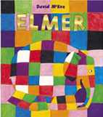    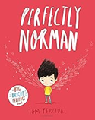  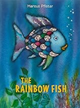    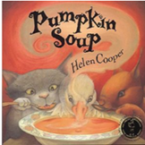  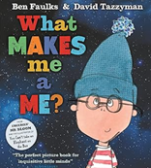    Key Texts / Vocabulary  roar, anger, temper, calm, feelings anger, temper, calm, feelings  different, wings, secret, brave, accept  shimmering, scales, share, lonely, friendship  colourful, patchwork, celebrate, proud, different  unique, personality, identity, special, belong  recipe, quarrel, ingredients, stir, share  strong, unusual, amazed, surprised, powerful
Me and My Relationships  Democracy | My Musical Heartbeat | Church visit – Harvest
Sequence of lessons:  - My Feelings  - My Feelings  - Good friends  - How are you listening?  - Types of bullying | Sequence of lessons:  SONG 1 Find The Beat Style: Hip Hop  SONG 2 1-2-3-4-5 Style: Jazz  SONG 3 Head, Shoulders, Knees And Toes Style: Hip Hop  SONG 4 Shapes Style: Pop  SONG 5 We Talk To Animals Style: Pop  SONG 6 We Are Together Style: Soul | Sequence of lessons:  1. Why God is important to Christians ? (linked to the creation story)  2. Why do Christians celebrate harvest?  3. How do Christians take care of the world?  4. How can I take part in a harvest festival?  5. Why do Christians refer to God as ‘hallowed’ in the lords prayer?  6. What do I want to keep safe in my life and why?
Outcome: | Outcome:  Children perform a selection of songs during Learning showcase. | Outcome:  Children take an active part in the Harvest festival. School council will take food donations to Helston Food Bank.
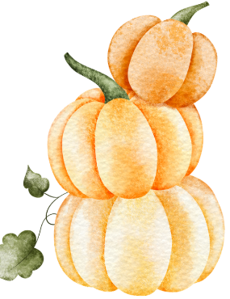
Maple Class Learning Showcase
2.30pm – 3.15pm Thursday 23rd October

Come and see our learning!

