
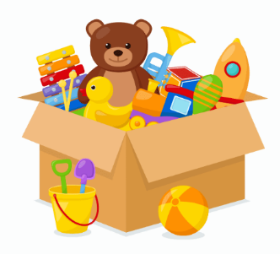
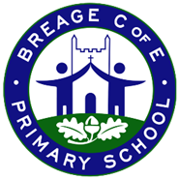
Class KS1 Curriculum - Autumn 2
Key Questions -What can we celebrate?
Have toys changed since our grandparents were young and how do we know?
History | Science | DT | PE | Computing
How have toys changed?  Grandparents afternoon visit | How can we group animals? | Mechanisms: Sliders and Levers  How can we make moving pages? | Fundamentals: Unit 1  Dance: Unit 1  Ball Skills  Dance | Winter Warmers  Technology & Computer Systems Around Us
Sequence of lessons:  - How can we find out about the past?  - What are toys like now?  - What was my favourite toy when I was a baby?  - What were our parents’ toys like? How do we know?  - What were our older relatives’ toys like? How do we know?  - How have toys changed since our older relatives? | Sequence of lessons:  - What is this animal?  - How are animals different?  - Do all animals eat the same thing?  - What are our body parts called?  - What are senses?  - Are all humans the same?  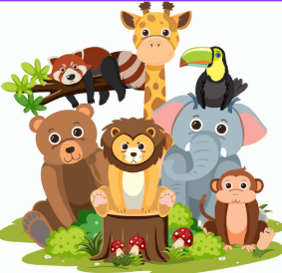 | Sequence of lessons:  Lesson 1 – What existing products use sliders and levers?  Lesson 2 – How do sliders and levers work?  Lesson 3 – Can I design a moving page with a slider and lever?  Lesson 4 – Can I use my design to make a moving page with a slider and lever?  Lesson 5 – Is my final product successful? How do I know this? | Sequence of lessons:  - To develop dribbling with your hands.  - To explore accuracy when rolling a ball.  - To explore throwing with accuracy towards a target.  - To explore catching with two hands.  - To explore dribbling a ball with your feet.  - To explore tracking a ball that is coming towards me. | Sequence of lessons:  - What is IT?  - IT in school  - IT in the world  - The benefits of IT  - Using IT safely  - Using IT in different ways
Outcome:  Children will form a written response to the enquiry for this unit, How do we know that toys changed since our grandparents were young? | Outcome:  Create a poster displaying different types of animals based on the classifications: mammals, birds, reptiles, amphibians, and fish. | Outcome:  Make a moving Christmas card. | Outcome:  I can catch with 2 hands.  I can dribble a ball with my hands and feet.  I can roll towards a target.  I’m beginning to understand simple tactics. | Outcome:  Design a poster that highlights key rules about using IT safely.

PSHE | Music | RE | 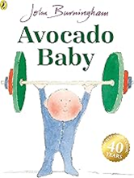  Key Texts / Vocabulary  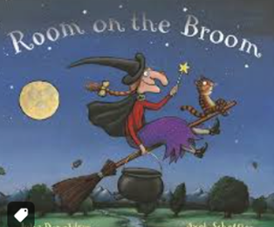  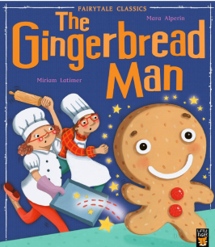  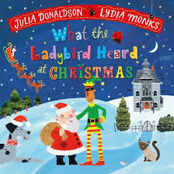  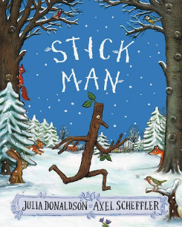  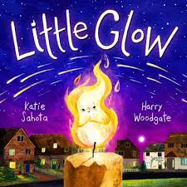  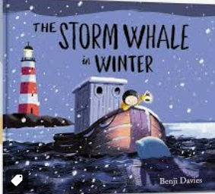  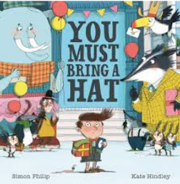  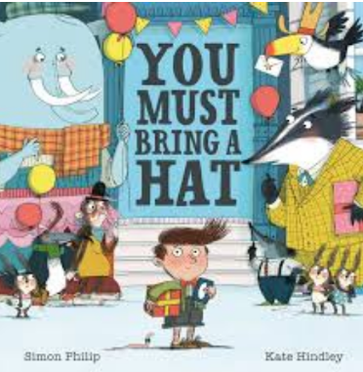  invitation, party, guest, surprise, rule  ladybird, whisper, Christmas, plan, thieves  branch, river, chimney, family, adventure  chase, oven, run, trick, river  broomstick, cauldron, spell, dragon, witch  storm, rescue, island, whale, winter  light, candle, sparkle, festival, together
Valuing Differences  Mutual Respect | Playing in an Orchestra | Why do Christians perform Nativity plays at Christmas?  Why does Christmas matter to Christians?
Sequence of lessons:  - I am caring  - It’s not fair  - When someone is feeling left out  - An act of kindness  - Solve the problem  - Let’s celebrate our difference | Sequence of lessons:  - Sparkle in the Sun (part 1)  - Sparkle in the Sun (Part 2)  - Listen to the world around you (part 1)  - Listen to the world around you (part 2)  - The orchestra song  - Assessment chackpoint | Sequence of lessons:  - What is the history of Nativity plays?  - Who are the key characters in a Nativity play?  - Why is the Nativity story significant?  - Why are Nativity plays performed at Christmas?  - What are personal experiences of Nativity plays?  - How can we create a simple Nativity scene?
Outcome:  What Makes a Good Friend  Describe the qualities of a kind and respectful friend.  Understand that friends can be different from themselves.  Know how to offer support to others who are upset or excluded. | Outcome:  Children perform their music as part of the Learning showcase. | Outcome:  Can children perform the Nativity story, retelling key events.
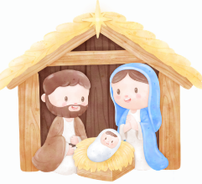
Grandparents Afternoon
Grandparents are invited to come and talk
about toys when they were children.
Maple Class Learning Showcase
Nativity performances – 10th & 11th December

Come and see our learning!

