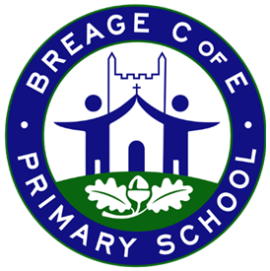
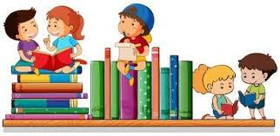
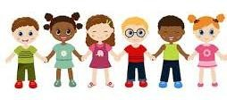

Specific Areas
Literacy
Listening to key texts related to the topic. Learning to read simple sounds (phonemes) and to write them (graphemes). Practising segmenting and blending sounds together to read and write simple cvc words. Learn some high frequency words.

Maths
Representing, comparing and composition of number 1,2 and 3. Representing numbers to 5. Finding one more and one less.

Autumn Term
Maple Class - EYFS

Prime Areas
Personal, Social and Emotional Development –
Building on friendships and continuing to develop sharing, turn taking and good listening skills with our friends. Naming and exploring feelings and emotions and learning strategies to self-regulate emotions when upset or angry. Our SCARF topic is “Valuing Difference”.

Communication and Language –
New vocabulary. Listening to and joining in with rhymes and stories (non-fiction and familiar stories). Asking questions and responding to others to gain more information and continue dialogue. Talk about ourselves and express interests and share experiences.

Physical Development –
Continue to develop a strong tripod pencil grip and practice correct letter formation. Use scissors and other tools to make changes to materials. Develop rhythm and movement. Change speed and be able to stop and be still. Developing ball skills (using hands and feet)

What can we celebrate? / How have toys changed?
Overview
This half term we will be exploring our natural environment and finding out about the different animals that live in the woods. Our key texts include: Room on the Broom, The three little pigs, the Gingerbread man, You must bring a hat, The Storm Whale in Winter, Stick Man, Little Glow and What the Ladybird Heard at Christmas. We will also be learning about the Christmas story and exploring different Christmas customs as we enter the festive season.

Understanding the World – Identify the changes in the season of Autumn. Name and describe the different animals. Talk about how and where they live. Investigate and experience outdoor adventure. Talk about their own experiences in the place where they live and things that we do with our families. Our RE focus for this half term is ‘Why is Christmas important for Christians?’
Expressive Arts and Design – Learn to sing some new Autumn/Winter songs with actions. Use simple percussion to tap rhythms and beats. Dance and movement to music. Christmas crafts with different media and materials.

Learning at Home – You can support your child’s educational development by completing homework together.

 | What is expected | When will it be given?
Reading | Children will choose a library book every Monday. Please read this to / with your child and record in the Reading record. Use the Little Wandle flashcards to practice any sounds we learn over the coming weeks. Your child will also bring home a Little Wandle reading book – this is for them to read to you and to encourage discussion. | Monday
Writing | Please encourage children to practice  writing their name using correct letter formation. | On going
Maths | Please practice simple counting, matching and sorting activities. | See KIRF sheets
UtW | Encourage children to make links in their wider learning through prompt questions on the weekly learning overview on Tapestry | Weekly

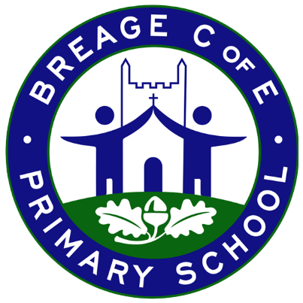
Intended Outcome
The children will be able to name and talk about different animals and explain where and how they live. They will confidently observe and talk about Toys they play with now and how toys have changed. The children will be able to talk about seasonal change and the festivals and celebrations during this winter season. They will begin to understand and talk about festivals they celebrate at home and in their community.

Some Key Diary Dates
(Check the newsletter for the most up-to-date info)
November
Mon 3 Return to school
Mon 3 Week 1 of Aspens new Autumn/Winter menu
Thurs 6 Aspens special menu: Sparkle Spectacular (see ParentPay)
Mon 10 Paediatric Hearing Screener
Aspens workshop with Oak class
Tues 18 Aspens workshop with Maple class
December
Weds 10 Nativity afternoon performance (2pm)
Thurs 11 Nativity performance (5pm)
Thurs 18 Christingle / Carol service
Frid 19 Last day of school before Christmas break
January
Mon 5 Return to school

This overview shows the intended learning, which may change due to pupil interests.

