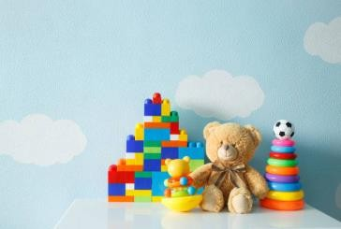
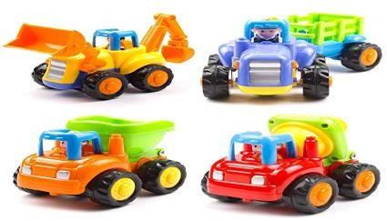
Toys - Key Stage 1
Geography
Choose two or three different countries from around the world and discover what toys children in these countries play with. What is different and similar to toys we play with? What causes these comparisons?
I.e. wealth, environment
Science – AT1 opportunities
Using toys cars, investigate which material on a ramp allows the car to travel the fastest.
Using toy boats, conduct an experiment about how much weight it can take (use plasticine) before it sinks.
Reading
Old Bear - Jane Hissey
The night the toys came to life - Enid Blyton
The Velveteen Rabbit - Margery Williams
Music
Explore the music from Toy Story and discuss them each alongside a clip of the film they are played alongside.
How does the piece of music match the script for the section?
Learn the signing / lyrics for ‘You’ve got a friend in me’.
Role play area:
Create a toy shop for the children to explore. Involve the children in the development of it so they can create the price labels, shelf labels and organise their stock. Include a till and money to encourage development of maths skills.
History
Study the history of toys with the children.
Start by looking at modern toys – what are the children’s current favourite? Watch a series of toy adverts. Look through catalogues. What is similar about the toys being sold today? Can they be categorised?
Focus on bears and show the children images (or real-life examples if you can) of bears throughout the past. What changes about bears through history? What stays the same?
As above – study moving toys and consider the changes over time.
If possible, to arrange invite visitors of various ages in to class to be interviewed by the children about the toys they played with as children.
Hook – Ideas to ignite interest and excitement from all learners
Show the children a selection of images of staff members that are familiar to them as well as either images or artefacts of a range of toys. Children to discuss and match the toys to the staff. Whose toys is whose? Are there any clues they could use? I.e. are some staff members older than others and therefore their toys are older?
PSHE
Discuss the emotions children feel when they get a new toy. What if you couldn’t ever have a new toy again? How would you feel?
Introduce a charity local to you that supports vulnerable families and explain that you would like each of the children to donate one of their own toys to a child less fortunate than themselves. Children to write a note with their chosen toy they will donate. It would be a great if a volunteer from the charity could come and speak to the children and then show them photos of their toys being used by the children they were gifted to.

Maths
Using the role play toy shop introduce children to making amounts using coins, adding up totals and calculating change. Try to use real money wherever possible.
Writing
Write instructions for taking care of their toy.

Write an explanation for how a moving toy of their choice works. Write an adventure story based on their favourite toy.
Computing
Children to write a profile for their favourite toy. Add an image. Format text to bold the subtitles and underline as well as typing the content. Save their documents to be re-opened successfully for editing in the subsequent lessons.
Art
Portraits - Using their favourite toy children to create portraits using different media. Discuss facial feature positioning and model adding detail, shade and contrast using the different media. Children to display four of their portraits to create a quadrant of portraits of the same toy in different media.
Design and technology
Using a range of construction materials children to build a bridge that will allow a toy car to move from one side of a imaginary river to the other. Show children images of famous bridges so that they can develop their understanding of strong shapes for their construction.

Show children a clip from a Punch and Judy puppet show. Children to explore a range of puppets - finger, hand, string, stick. Children to design and create a range of stick puppets in a group to create a puppet show that can be performed to the class.

